ALEXANDRIA TOWNSHIP
Land Use/Building Permit Application

Site Address (E-911#): | Parcel Number (9 digits):
______________________________________________ | __ __ - __ __ __ __ - __ __ __

Legal Description (Lot, Block & Subdivision Name or attach full legal description):

Lake Name (if applicable): | E911 Address Needed? Yes No

Property Owner Info:
Name:
Mailing Address:
City: | State: | Zip Code:
Home Phone: | Cell Phone: | Fax Number:

Applicant Info:
Name:
Mailing Address:
City | State: | Zip Code
Home Phone: | Cell Phone: | Fax Number:

Applicant Is: | Owner | Licensed Contractor | Design Prof. | Contract Buyer | Other: _______

Type of Improvement(s) – check all that apply:
Addition | Build New | Demolish |  | Move | Mechanical Only |  | Plumbing Only
Interior Alteration/Repair (interior remodel, basement finish, etc…) |  |  | Structural Alteration/Repair  (exterior walls, roof replace, etc…) |  |  | Maintenance (Replace siding, windows, shingles, doors)

Structure Information:
Structure #1 |  |  | Structure #2 |  |  | Structure #3
Type of Structure:  Dwelling  Storage Building  Detached Gar.  Attached Gar.  Open Deck  Roofed Deck  Enclosed Porch  Patio  Other  ______________ | Use:  Residential  Industrial  Commercial  Other  Foundation:  Full Bsmnt  Partial Bsmnt  Slab-on-Grade  Piers  Other |  | Type of Structure:  Dwelling  Storage Building  Detached Gar.  Attached Gar.  Open Deck  Roofed Deck  Enclosed Porch  Patio  Other  ______________ | Use:  Residential  Industrial  Commercial  Other  Foundation:  Full Bsmnt  Partial Bsmnt  Slab-on-Grade  Piers  Other |  | Type of Structure:  Dwelling  Storage Building  Detached Gar.  Attached Gar.  Open Deck  Roofed Deck  Enclosed Porch  Patio  Other  ______________ | Use:  Residential  Industrial  Commercial  Other  Foundation:  Full Bsmnt  Partial Bsmnt  Slab-on-Grade  Piers  Other
Footprint (sq ft) _______  Total Floor Space ______  Height (ft) ______  Roof Pitch ______  Eave Width (ft) ______ |  | Plumbing in Building?  Yes No  If Yes:  ALASD Private | Footprint (sq ft) _______  Total Floor Space _____  Height (ft) ______  Roof Pitch ______  Eave Width (ft) ______ |  | Plumbing in Building?  Yes No  If Yes:  ALASD Private | Footprint (sq ft) _______  Total Floor Space _____  Height (ft) ______  Roof Pitch ______  Eave Width (ft) ______ |  | Plumbing in Building?  Yes No  If Yes:  ALASD Private
Estimated Cost: $______________________ |  |  | Estimated Cost: $______________________ |  |  | Estimated Cost: $______________________

Describe the Proposed Improvement/Project (note type of structure(s), number of stories, any associated grading or landscaping associated with the project, and other relevant info not already mentioned):

Contractor: |  | MN License Number:
Mailing Address:
City | State: |  | Zip Code:
Business Phone: | Cell Phone: |  | Fax Number

Design Professional/Architect: |  | MN License Number:
Mailing Address:
City | State: |  | Zip Code:
Business Phone: | Cell Phone: |  | Fax Number

Excavator: |  | Contact Person:
Mailing Address:
City | State: |  | Zip Code:
Business Phone: | Cell Phone: |  | Fax Number

Plumbing Contractor: |  | Contact Person:
Mailing Address:
City | State: |  | Zip Code:
Business Phone: | Cell Phone: |  | Fax Number

Heating Contractor: |  | Contact Person:
Mailing Address:
City | State: |  | Zip Code:
Business Phone: | Cell Phone: |  | Fax Number

Signature of Applicant*: ______________________________________________ | Date: __________
Signature of Title Holder* (required): ___________________________________ | Date: __________

* By signing, the applicant or agent hereby makes application for a permit to construct as herein specified, agreeing to do all such work in strict accordance with all Alexandria Township and other applicable ordinances or federal and state laws. Applicant or agent agrees that site plan, sketches, and other attachments submitted herewith and which are approved by the Alexandria Township Zoning Administrator are true and accurate, and shall become part of the permit. Applicant or agent agrees that, in making said application for a permit, applicant grants permission to Alexandria Township’s designated zoning or building inspection officials, at reasonable times during the application process and thereafter, to enter applicant’s premises covered by said permit, to determine the feasibility of granting said permit or for compliance of that permit with any applicable township, state, or federal ordinances or statutes. Applicant or agent understands that it is applicant’s sole responsibility to contact any other federal, state, county or local agencies to make sure applicant has complied with all relevant Municipal, State, Federal or other applicable laws concerning applicant’s project described above.

SKETCH DRAWING INSTRUCTIONS

A sketch of your site plan is a required part of the permit application. Please attach on a separate sheet of paper.

EXAMPLE SKETCH:
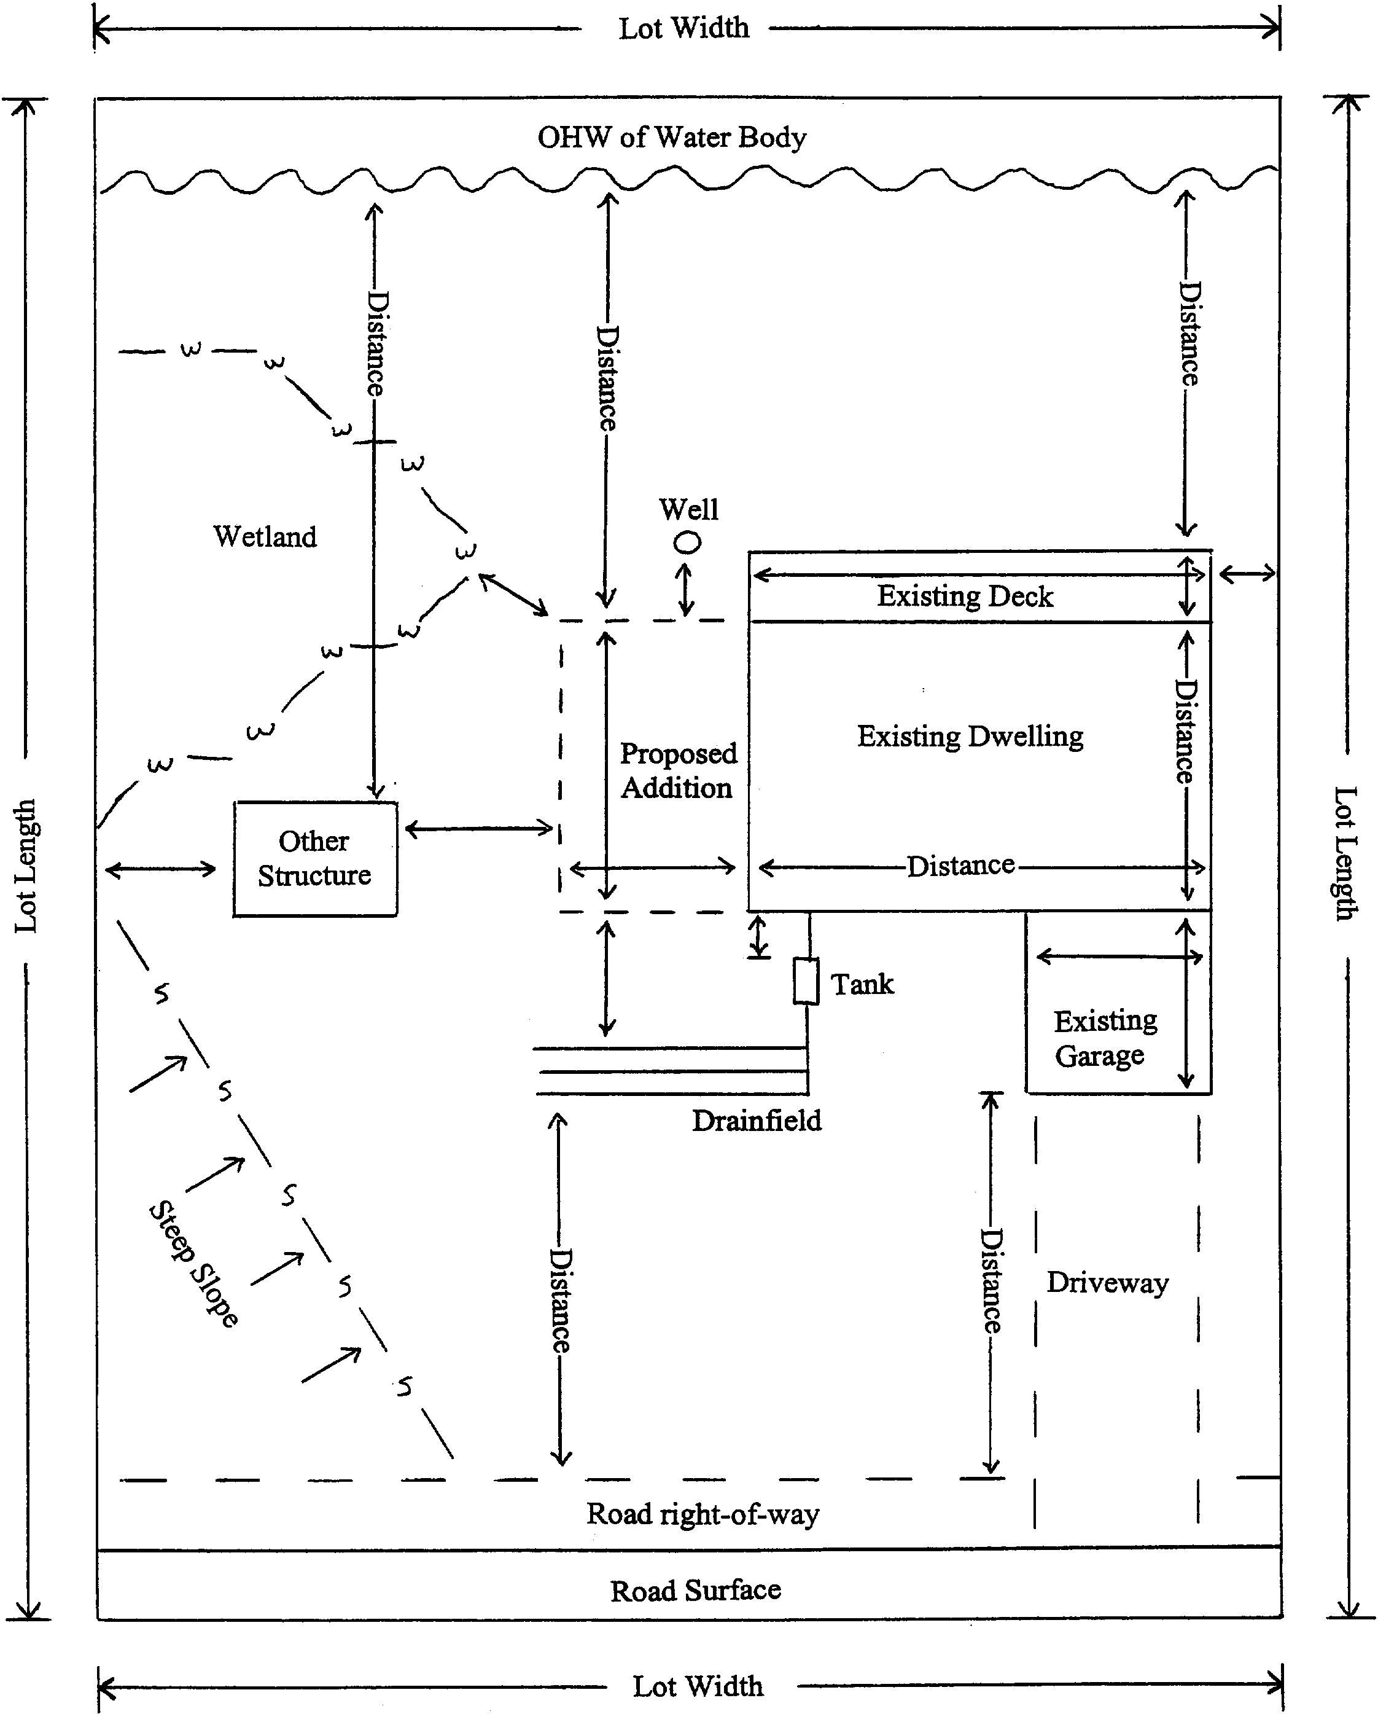Required Information:
- North arrow
- Lot dimensions and size
- Waterbodies and wetlands
- Roads, right-of-ways, driveways and parking areas
- Existing Easements
- Existing structures, with outside wall dimensions
- Proposed structures, with outside wall dimensions
- All impervious (i.e. hard surfaced) structures not already identified (i.e. driveways, decks, patios, sidewalks, retaining walls, areas underlain with landscape fabric, etc…). Show dimensions.
- Well and septic system location, if applicable
- Bluff (>30% slope) or steep slopes (12-30%) and direction of slope, if applicable
- Setback distances from existing and proposed structures to lot lines, waterbodies, any part of a bluff, private sewers, wells, and road centerline.
- Other information that may be necessary or required by the Zoning Administrator to describe your proposed improvement. These may include:
- Elevation of Ordinary High Water Level (OHW)
- Slope information (elevation contours)
- Professionally delineated wetland boundaries (contact Douglas Co. Soil & Water Conservation District)
- Professional survey of all impervious surfaces (generally required when estimated impervious surface coverage is 23% or higher

REQUIRED LOT SURVEYS: The Zoning Administrator will determine whether you are required to submit a property line survey. Generally, if your proposed structure will be within 5-10 feet of the required minimum setback, or when it is otherwise unclear whether you will meet a required setback, a property line survey will be required. If you already have had a property line survey completed, please submit a copy as part of your application to determine whether it is sufficient to avoid the need for another survey.

SKETCH DRAWING

Impervious Surface Calculation
List all existing structures* or other improvements on the property and their outside dimensions |  | List all proposed structures* or other improvements on the property and their outside dimensions:
Type of Structure or Improvement | Footprint –  incl. eaves (sq ft) | Type of Structure or Improvement | Footprint –  incl. eaves (sq ft)
1.
2.
3.
4.
5.
Total |  | Total
*Note: Include all roofed structures (including eaves), patios, decks, driveways, parking areas, retaining walls, stairways, sidewalks, propane tanks, landscaping underlain with fabric/plastic, etc…
Total Lot Size = ___________sq ft or acres

Total Impervious Coverage (Total Impervious / Total Lot Size) * 100 = ___________%
ALEXANDRIA TOWNSHIP
LAND USE/BUILDING PERMIT APPLICATION

APPLICATION:

Applicant shall complete Land Use/Building Permit Application and submit to the Township.

- Land Use/Building Permits: The Township has adopted the Minnesota State Building Code (effective January 1, 2008) in addition to the previously adopted Zoning Ordinance (effective January 1, 2007). One or both of these regulations applies to the construction, alteration, moving, demolition, repair, and use of any building, structure, or building service equipment. This includes decks, patios, and any other structures or buildings. They also apply to a change in how a building, structure or property is used (i.e. changing from a residential use to a commercial use). Please contact the Township Zoning Administrator to determine if your project is subject to permit requirements. Two (2) sets of construction plans are required for permit applications that require a building permit.
- Minimum Width of Dwelling: A dwelling on a parcel of land in all zoning districts must meet the width and depth requirement of 24 feet.
- Annexation Areas: Property owners within the future annexation areas (generally located between the City and the Chain of Lakes) are subject to City of Alexandria zoning and building code requirements. Contact the City at 320-763-6678.

REVIEW:
- All applications are to be submitted to the Township Office in person at 324 Broadway, Ste. 101 or by mail at PO Box 445, Alexandria, MN 56308. No fees are due at the time of application.
- The application will be initially reviewed for completeness by the Township. If incomplete, the application will be returned to you for additional information.
- The application will be reviewed by both the Building Inspector and the Township Zoning Administrator to determine whether it meets the requirements of the Township ordinances and the Minnesota State Building Code.
- The applicant will be notified when the application is approved (please allow up to two weeks for approval – actual review time may be less). Required fees must be paid at the time you pick up your permit.
- The applicant will be issued a permit card that must be posted in a visible place on your property during construction.

ACTION:
In order to obtain a Land Use/Building Permit, the following may be required:
- Two (2) sets of construction plans.
- A verification of connection to a central sewage treatment system, a certificate of compliance for an existing individual sewage treatment system or an individual sewage treatment system design must be submitted and approved by the Zoning Administrator prior to the issuance of any permit for a building/structure containing plumbing.
- Township staff may verify that there are no outstanding violations on the property and that any conditions of a previously granted conditional use permit or variance have been met.
- Township staff must ensure that the permit fee has been collected.
- The Zoning Administrator must ensure that the proposed improvements meet the requirements of the Ordinance.

PLEASE NOTE: The Township has 60 days in which to review and make a decision on land use applications, although the Township strives to process all applications as soon as they are received. To avoid delays, applicants should allow themselves as much time as possible between the time they submit their application and the time they wish to begin construction. Close coordination with the Township Staff during the project design phase and submittals that are complete and accurate will help applicants avoid delays. No construction can begin until the permit is complete and approved.

